**LONGDEN VILLAGE HALL**

**IMPORTANT INFORMATION**

For Hirers or in the case of a booking by an organisation, the authorised representative, must ensure that all precautions are taken against risk of FIRE and damage to the property.

The Hall has no telephone on the premises. Please ensure you have a mobile in good working order with you. All means of EXITS from the premises must be kept free from obstruction and immediately available for instant public exit. They must not be used except in an emergency. The emergency exit illuminated signs remain on permanently.

Smoking is not allowed in the building, and neither is the use of candles (battery/LED candles are permitted).

**Opening and closing the village hall**

Arrangements for access to the hall will be made shortly before your hire – please contact lvhbooking@outlook.com a few days before the event. All bookings are calculated from the time of arrival at the building to the time you leave. Please ensure that any outside caterers, contractors and bar staff are aware of the hire period and that they will not be able to enter before or leave after the hire period. The Hall is in a residential area, so music must be played at a reasonable level and be finished by 11.00pm. All guests must have left the Hall and Car Park by midnight. Please ask them to leave quietly. Car doors banging and loud talk in the car park are a disturbance for local residents.

**Furniture**

Please use the trolleys provided for moving chairs and tables in order to avoid injury. Please stack chairs and tables neatly in the storerooms. A first aid box and Accident Report book is located in the kitchen. All recorded accidents must be reported to the Hall administrator as soon as possible.

**Heating**

The heating system is operated from the Kitchen, if heating is needed please override the control panel to constant and switch back off after use.

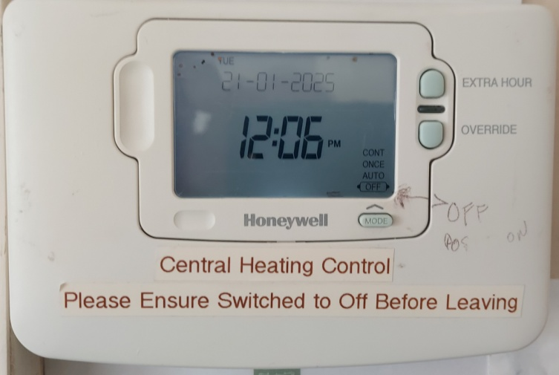

Click this button 3 times for constant heating, then once more for off.

**Health and Hygiene**

The Hirer shall, if preparing, serving or selling food, observe all relevant food health and hygiene legislation and regulations, in particular with the use of dairy products. Vegetables and meat must be refrigerated. Please request that the hall’s refrigerator be switched on prior to your event if required.

**Decorations**

You must not use drawing pins or tape on the walls or other surfaces and do not fix decorations near light fittings or heaters.

**Clearing up**

Please leave the village hall clean and tidy. In particular, we ask you to ensure tabletops are wiped clean before being stacked in the storeroom. Please remove all rubbish. We are a facility that contributes to local recycling efforts and request that you and your suppliers support us in this. Please do not throw bottles and other recyclables into our refuse bins. Please use the recycling bins supplied where possible. Use of the recreation facilities Longden Play area is a public facility owned and managed by Longden Parish Council and is available for use by the public. The Hirer should be aware that in the event of any accident occurring on the recreation ground to themselves or their guests during the period of hire, no claims can be made against Longden Village Hall. Use of the Recreation Ground in conjunction with the hall is at the discretion of Longden Parish Council, and if agreed, all outside activity must cease by 11.00pm or earlier, as directed by the Council.

Longden Parish Council has Public Liability Insurance for general public use of the Longden Play Ground. This Insurance does not specifically cover Public Liability for Hire of or part of the Recreation Ground for private events associated with hire of the Village Hall, including the use of equipment e.g. Bouncy Castles used for private events. The Hirer should ensure they have adequate Public Liability Insurance in place for the use of such equipment. Hirers should be aware that only the hall and adjoining patio may be reserved exclusively for private use; the Play area is a public facility. Faults/damage/comments please report any faults or damage to the Hall administrator as soon as possible so that they can be rectified quickly.

The management committee welcome comments or observations that you may have about your hire of the village hall. Payment For all provisional bookings payment is due upon receipt of an invoice. Please note that we do not accept cash, and cheques are only accepted by prior agreement at the time of booking. The Hirer is responsible for any costs incurred by Longden Village Hall in the event that any cheque so accepted results in bank charges being levied.